Formal Project Proposal Template
Due 7 March 2024
Name: | Farinaz Tanhaei
Programme: | MSC DATA SCIENCE
Student ID: | 23044867
Project Title: | Prediction of Coronary artery disease from patient symptoms
Problem you are seeking to address: | Coronary artery disease (CAD) is a condition when the primary blood vessels that supply the heart are plugged or obstructed [1]. This disease affects 2–9% of adults over the age of 20. To highlight its significance, we should point out that it caused 480 deaths every day [2].  Early detection can minimize the death risk from CAD. CAD can be detected using a variety of techniques, including cardiac CT scans and other types of data. But, in 2023 alone, 510000 CT scans were performed for various reasons in England [3]; hence, having a model that may reduce the number of CT scans can benefit the NHS.  In this effort, we want to forecast a patient's risk of developing CAD based on their symptoms. In this regard, we will employ the HEART DISEASE DATASET (COMPREHENSIVE) [4], which is composed of five different datasets. This dataset contains 1190 instances with 11 features. This enables us to train more trustworthy machine-learning models.
Aim and scope: | We believe a more systematic analysis of this data (as data investigation and preparation are preliminary right now) might give us a better result. We aim to gain a reliable result. For this reason, in addition to analysing data (knowledge learnt from the courses) and what other people have applied, we want to use XAI on the models to provide more trustworthy models.
Project objectives: | - Analysing the data and providing a comprehensive report.  - Applying different machine learning models (also ensemble learning).  - Performing XAI on the ML models
Expected project outcomes: | - Develop a comprehensive report that provides an in-depth analysis of the HEART DISEASE DATASET (COMPREHENSIVE).  - Include statistical analysis of the data but also insights into the patterns and correlations among different features.  - Detailed understanding of the data is expected to guide the subsequent stages of model development and validation.  - Apply various machine learning models, including ensemble learning techniques, to predict the risk of developing CAD.  - Achieve high accuracy in predicting CAD, surpassing the results of previous studies that used this dataset.  - Apply Explainable AI (XAI) techniques to these models.  - Enhance the trustworthiness of the models.  - Provide valuable insights into the factors that contribute most significantly to the prediction.  - We hope that our project will contribute to reducing the number of CT scans and thus benefit healthcare systems like the NHS.
Brief review of relevant literature: | Machine learning models have shown good accuracy in predicting CAD disease [5,6,7]. Many models have been applied for datasets related to CAD; however, using the HEART DISEASE DATASET (COMPREHENSIVE) is limited to two research as far as we are aware [8.9].  In most research, the dataset size was small [10,11], and applied models were limited [12]. These shortages have brought limitations to the results. In addition, there are some biases in model selection by the articles, such as [10], where applying SVM was limited to rbf and linear kernels. The data analysis was basic and simple.
[optional] References: | - NHS. (2014) Coronary heart disease. Available at: URL (Accessed: 19 02 2024).  - British Heart Foundation. (2014) BHF CVD Statistics - England Factsheet. Available at: https://www.bhf.org.uk/-/media/files/for-professionals/research/heart-statistics/bhf-cvd-statistics-england-factsheet.pdf (Accessed: 19 02 2024).  - NHS England. (2023) Statistical Release 22nd June 2023. Available at: https://www.england.nhs.uk/statistics/wp-content/uploads/sites/2/2023/06/Statistical-Release-22nd-June-2023-PDF-470KB.pdf (Accessed: 19 02 2023).  - Siddhartha, M., 2020. Heart Disease Dataset (Comprehensive). IEEE Dataport. doi: https://dx.doi.org/10.21227/dz4t-cm36.  - Mohapatra, S., Maneesha, S., Mohanty, S., Patra, P.K., Bhoi, S.K., Sahoo, K.S. and Gandomi, A.H., 2023. A stacking classifiers model for detecting heart irregularities and predicting cardiovascular disease. Healthcare Analytics, 3, 100133.  - Shah, D., Patel, S. and Bharti, S.K., 2020. Heart disease prediction using machine learning techniques. SN Comput. Sci., 1, p.345.  - Rajdhan, A., Agarwal, A., Sai, M., Ravi, D., Ghuli, P., 2020. Heart disease prediction using machine learning. International Journal of Research and Technology, 9(04), pp.659-662.  - Jia, H., Huang, Z., Caiafa, C.F., Duan, F., Zhang, Y., Sun, Z., Solé-Casals, J., 2023. Assessing the Potential of Data Augmentation in EEG Functional Connectivity for Early Detection of Alzheimer’s Disease. Cognitive Computation, 16, pp.229-242  - AKKUR, E., IBRAHİM, N., ABBAS, A., KHORSHEED, F., 2023. Prediction of Cardiovascular Disease Based on Voting Ensemble Model and SHAP Analysis. Sakarya University Journal of Computer and Information Sciences, 6(3), pp.226-238. Available at: URL (Accessed: Day Month Year).  - Rajdhan, A., Agarwal, A., Sai, M., Ravi, D., Ghuli, P., 2020. Heart disease prediction using machine learning. International Journal of Research and Technology, 9(04), pp.659-662.  - Poorani, S., Hemalatha, D., 2021. Machine Learning Techniques for Heart Disease Prediction. Journal of Cardiovascular Disease Research, 12(1), pp.93-96.  - Özhan, O., Küçükakçalı, Z., 2022. Estimation of risk factors related to heart attack with XGBoost that machine learning model. Middle Black Sea Journal of Health Science, 8(4), pp.582-591.
Testing and Evaluation: | - Analysing the data, linear correlation and non-linear correlations.  - divide the dataset into three parts: training, validation, and testing.  - Apply different ML models.  - Apply XAI on the best models.
Ethical considerations: | The data is already anonymised.
Project plan: | 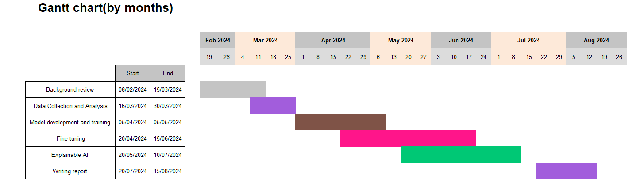
Signature: | Farinaz Tanhaei

Excluding your project title and references, your proposal should be a maximum of 1000 words in length. If using this template, then it would be at most 3 pages excluding references.

